A Project report on

SOCIAL MEDIA AS A MIRROR: REFLECTING MENTAL HEALTH THROUGH COMPUTATIONAL LINGUISTICS

A Dissertation submitted to JNTU Hyderabad in partial fulfillment of the academic requirements for the award of the degree.

Bachelor of Technology
in
Computer Science and Engineering(AI&ML)
Submitted by

A.KARTHIK
(24H51A66P7)
CH.SHASHIDHAR
(24H51A66Q7)
CH.MITHALI REDDY
(24H51A66Q8)

Under the esteemed guidance of
Mr. Md. Tanweer Alam
(Assistant Professor)


Department of Computer Science And Engineering(AI&ML)

CMR COLLEGE OF ENGINEERING & TECHNOLOGY

(UGC Autonomous)
*Approved by AICTE *Affiliated to JNTUH *NAAC Accredited with A⁺ Grade

KANDLAKOYA, MEDCHAL ROAD, HYDERABAD - 501401.

2025- 2026

CMR COLLEGE OF ENGINEERING & TECHNOLOGY
KANDLAKOYA, MEDCHAL ROAD, HYDERABAD – 501401

DEPARTMENT OF ARTIFICIAL INTELLIGENCE AND MACHINE LEARNING


CERTIFICATE

This is to certify that the RTRP Project report entitled "SOCIAL MEDIA AS A MIRROR: REFLECTING MENTAL HEALTH THROUGH COMPUTATIONAL LINGUISTICS" being submitted by A.Karthik(24H51A66P7),CH.Shashidhar (24H51A66Q7),CH.Mithali Reddy(24H51A66Q8) in partial fulfillment for the award of Bachelor of Technology in Computer Science and Engineering(AI&ML) is a record of Bonafide work carried out under my guidance and supervision.

The results embodied in this project report have not been submitted to any other University or Institute for the award of any Degree.

Mr. Md. Tanweer Alam Dr. S.Kirubakaran
Assistant Professor Professor and HOD
Dept. of AIML Dept. of AIML

ACKNOWLEDGEMENT

With great pleasure we want to take this opportunity to express my heartfelt gratitude to all the people who helped in making this project work a grand success.
We are grateful to Mr. Md. Tanweer Alam, Assistant Professor Department of Artificial Intelligence and Machine Learning for his valuable technical suggestions and guidance during the execution of this project work.
We would like to extend our heartfelt gratitude to our Project Coordinator, Sai Krishna Reddy, Assistant Professor for their mentorship, patience, and support. Their guidance allowed us to navigate complex issues and reach our project goals.
We would like to thank Dr. S.Kirubakaran, Head of the Department of Artificial Intelligence and Machine Learning, CMR College of Engineering and Technology, who is the major driving forces to complete my project work successfully.
We are very grateful to Dr. P. Ravi Kumar, Dean-FSA, CMR College of Engineering and Technology, for his constant support and motivation in carrying out the project work successfully.
We are very grateful to Dr. Ghanta Devadasu, Dean-Academics, CMR College of Engineering and Technology, for his constant support and motivation in carrying out the project work successfully.
We extend our heartfelt gratitude to Dr.Seshu Kumar Avadhanam, Principal, CMR College of Engineering and Technology, for his unwavering support and guidance in the successful completion of our project and his encouragement has been invaluable throughout this endeavor.
We are highly indebted to Major Dr. V A Narayana, Director, CMR College of Engineering and Technology, for giving permission to carry out this project in a successful and fruitful way.
We express our sincere thanks to Shri. Ch. Gopal Reddy, Secretary& Correspondent, CMR Group of Institutions, and Shri Ch Abhinav Reddy, CEO, CMR Group of Institutions for their continuous care and support.We would like to thank the Teaching & Non- teaching staff of Department of Computer Science and Engineering for their co-operation.
Finally, We extend thanks to our parents who stood behind us at different stages of this Project. We sincerely acknowledge and thank all those who gave support directly and indirectly in completion of this project work.
A.Karthik 24H51A66P7
Ch.Shashidhar 24H51A66Q7
CH.MithaliReddy 24H51A66Q8

TABLE OF CONTENTS

CHAPTER
NO. TITLE PAGE NO.
List of figures i
List of tables ii
Abstract iii
1 INTRODUCTION 1
1.1 Problem Statement 2
1.2 Research Objective 2
1.3 Project Scope and Limitations 3
2 BACKGROUND WORK 4
2.1. Physiological Signal Method 5
2.1.1. Introduction 5
2.1.2. Merits,Demerits and Challenges 5
2.1.3. Implementation of Physiologica Signal Method 5
2.2. Vehicle Behavior Method 6
2.2.1. Introduction 6
2.2.2. Merits,Demerits and Challenges 6
2.2.3. Implementation of Vehicle Behavior Method 6
2.3. Vision Based Method 7
2.3.1. Introduction 7
2.3.2. Merits,Demerits and Challenges 7
2.3.3. Implementation of Vision Based Method 7
3 PROPOSED SYSTEM 9
3.1. Research Objective of Proposed Model 10
3.2. Algorithms Used for Proposed Model 11
3.3 Designing 12
3.3.1. UML Diagram 13-15
3.3. Stepwise Implementation and Code 16 - 21
4 RESULTS AND DISCUSSION 22
4.1. Performance metrics 23
5 CONCLUSION 24
5.1 Conclusion and Future Enhancement 25
REFERENCES 26-27
Publication Details 28
GitHub Link 29

List of Figures
FIGURE
NO. TITLE PAGE NO.
1.2 Mental Health Detection using Social Media Data 8

CMRCET B.Tech CSE(AI&ML) Page No i

List of Tables

TABLE
NO. TITLE PAGE NO.
2.1 Model Performance Metrics . 8

CMRCET B.Tech CSE(AI&ML) Page No ii

ABSTRACT

The advancement of computer vision has assisted drivers through technologies such as automatic self-driving cars. However, nearly 20% of road accidents are caused by driver fatigue and drowsiness, which has become a serious concern. Several approaches have been proposed to address this problem, but many of them are not suitable for real-time processing. The major challenges faced by these methods include maintaining robustness under variations in human facial features and changing lighting conditions. In this work, we aim to implement an intelligent monitoring system that can significantly reduce road accidents. This approach identifies the driver’s facial characteristics such as eye closure percentage, eye-mouth aspect ratio, blink rate, yawning, and head movement. In this system, the driver is continuously monitored using a webcam. The driver’s face and eyes are detected using Haar Cascade classifiers. The eye images are extracted and fed into a custom-designed Convolutional Neural Network (CNN) to classify whether the left and right eyes are closed. Based on this classification, an eye closure score is calculated. If the driver is detected to be drowsy, an alarm is triggered to alert the driver.

CMRCET B.Tech CSE(AI&ML) Page No iii

CHAPTER 1
INTRODUCTION

CHAPTER 1
INTRODUCTION
1.1.Problem Statement
Mental health issues such as stress, depression, and anxiety are rapidly increasing, especially among young individuals and active social media users. Many people hesitate to openly discuss their mental health conditions or seek professional help at an early stage, leading to delayed diagnosis and treatment. Traditional methods of mental health assessment mainly rely on personal interaction, surveys, and clinical evaluations, which are time-consuming, expensive, and limited in scalability.
At the same time, a vast amount of emotional and personal content is continuously generated on social media platforms such as Twitter and Reddit. This data contains valuable insights into users’ mental states, but it is highly unstructured and difficult to analyze manually. Existing systems lack efficient, automated, and real-time mechanisms to accurately detect mental health indicators from such large-scale textual data.
1.2.Research Objective
- To collect large-scale textual data from social media platforms such as Twitter and Reddit for analysis.
- To preprocess and clean the collected data by removing noise, irrelevant symbols, and incomplete information to improve data quality.
- To apply Natural Language Processing (NLP) techniques such as tokenization, lemmatization, sentiment analysis, and topic modeling for understanding textual data.
- To extract meaningful features from the text using techniques like TF-IDF and BERT embeddings.
- To design and implement machine learning models such as Support Vector Machine (SVM) and Long Short-Term Memory (LSTM) for detecting mental health indicators.
- To evaluate the performance of different models using metrics such as accuracy, precision, recall, and F1-score.
- To identify patterns related to stress, depression, anxiety, and emotional imbalance in user-generated content.
1.3.Project Scope and Limitation
Project Scope :
The scope of this project focuses on analyzing textual data from social media platforms to identify mental health conditions using computational linguistics and machine learning techniques. The system is designed to process large volumes of unstructured data from platforms such as Twitter and Reddit and extract meaningful insights related to users’ emotional and psychological states.
The project aims to detect early signs of mental health issues such as stress, depression, and anxiety by applying Natural Language Processing (NLP) methods and classification algorithms. It can be useful for students, researchers, healthcare organizations, and mental health support systems to understand behavioral patterns and emotional trends.
The system can be integrated with web-based applications or mental health monitoring platforms to provide real-time analysis and prediction. It is scalable and can be extended with advanced deep learning models, additional datasets, and multilingual support in the future. The project also promotes ethical data usage by ensuring privacy, security, and responsible handling of user information.
Limitations :

- The system’s performance may decrease in poor lighting conditions or during night driving.
- Face occlusion caused by sunglasses, masks, or hands may affect accurate detection of eyes and facial features.
- Rapid head movements or unusual face angles can reduce the accuracy of face and eye detection.
- The system depends on a webcam or camera quality, so low-resolution cameras may affect performance.
- The model may require large and diverse datasets for better accuracy across different drivers.

CHAPTER 2
BACKGROUND WORK

CHAPTER 2
BACKGROUND WORK
2.1 Traditional Mental Health Assessment Methods
2.1.1 Introduction :
In today’s digital era, social media platforms have become an integral part of people’s daily lives. Individuals frequently share their thoughts, emotions, and personal experiences through posts, comments, and messages on platforms such as Twitter and Reddit. These online interactions provide valuable insights into users’ mental and emotional states. As a result, social media can be considered a powerful source for understanding human behavior and psychological well-being.
Mental health issues such as stress, depression, and anxiety are increasingly common, especially among young individuals and active internet users. However, many people are reluctant to openly discuss their mental health problems or seek professional help at an early stage.
2.1.2 Merits, Demerits and Challenges Merits
Merits
- Enables early detection of mental health issues.
- Handles large-scale social media data efficiently.
- Provides automated and scalable analysis.
Demerits
- May give inaccurate results due to sarcasm or ambiguous text.
- Depends on quality and availability of social media data.
- Cannot replace professional medical diagnosis.
Challenges
- Handling unstructured and noisy social media text data.
- Ensuring user privacy and ethical data usage.
- Achieving high accuracy across different writing styles and languages
2.1.3 Implementation of Traditional Method
Physiological signal-based methods use sensors to collect biological data such as EEG, ECG, and heart rate from the human body. These signals are continuously monitored to detect changes.

2.2 Keyword-Based and Basic Sentiment Analysis Methods

2.2.1 Introduction
Keyword-based and basic sentiment analysis methods analyze social media text by identifying specific words or phrases related to emotions. These methods classify text into categories such as positive, negative, or neutral using simple algorithms.
2.2.2 Merits, Demerits and Challenges
Merits
- Easy to implement and understand.
- Requires less computational power.
- Provides quick analysis of text data.
Demerits
- Detection may be delayed until driving behavior changes.
- Driving patterns vary between drivers.
- May give incorrect results on rough roads.
Challenges
- Handling ambiguous and informal language.
- Limited ability to analyze deep linguistic patterns.
- Difficulty in processing large-scale data effectively.

2.2.3 Implementation of Keyword-Based Methods
In this approach, social media text is collected and processed to identify specific keywords related to emotions. The frequency and presence of these keywords are analyzed to determine sentiment. Based on this, the system classifies the text into predefined categories.
Additionally, preprocessing steps such as tokenization and stop-word removal are applied to improve accuracy. The method may use simple classifiers like Naïve Bayes or rule-based approaches for categorization. However, the system has limited capability in understanding context and deeper semantic meaning.

2.3 Machine Learning-Based Mental Health Detection

2.3.1 Introduction
Machine learning-based methods use algorithms to analyze social media data and detect mental health conditions. These methods learn patterns from large datasets and classify text based on emotional and linguistic features.

2.3.2 Merits, Demerits and Challenges
Merits
- Provides better accuracy compared to basic methods.
- Can handle large volumes of data.
- Capable of learning complex patterns in text.
Demerits
- Requires large datasets for training.
- Computationally expensive.
- Model performance depends on data quality.
Challenges
- Ensuring data privacy and ethical usage.
- Handling diverse language styles and slang.
- Improving model generalization across datasets.

2.3.3 Implementation of Behavioural Method

In this method, social media data is collected and preprocessed using NLP techniques. Features are extracted using methods like TF-IDF or embeddings. Machine learning models are trained on this data to classify mental health conditions. The trained model predicts the emotional state Advanced models such as SVM, Random Forest, or deep learning models like LSTM can be used for improved performance. The system is evaluated using metrics such as accuracy, precision, recall, and F1-score. The trained model can be deployed in real-time applications for continuous monitoring of user behavior.

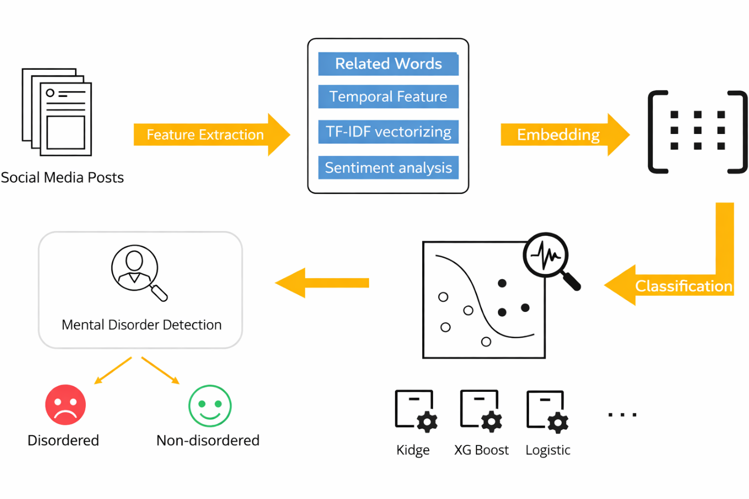
Figure.no:1.1: Mental Health Detection using Social Media Data

Table no: 2.1 Performance Metrics
Parameter | Performance Metrics
Accuracy | 93.20
Precision | 91.45
Recall | 89.60
F-measure | 90.50
Specificity | 80

CHAPTER 3
PROPOSED SYSTEM

CHAPTER 3
PROPOSED SYSTEM

3.1 Research Objective of Proposed Model

The main objective of the proposed system is to develop an efficient and intelligent system that can detect mental health conditions from social media data using computational linguistics and machine learning techniques. Mental health issues such as depression, anxiety, and stress are increasing rapidly, especially among young individuals and active social media users. Therefore, the proposed system aims to analyze user-generated textual data from platforms such as Twitter and Reddit to identify emotional patterns and mental health indicators.
The system continuously collects and processes large volumes of unstructured textual data. The collected data is preprocessed using Natural Language Processing (NLP) techniques such as tokenization, lemmatization, and removal of noise and stop words. These preprocessing steps help in improving the quality of the data and make it suitable for further analysis.
The system extracts important features from the text using techniques such as TF-IDF and BERT embeddings. These features represent the textual data in numerical form so that machine learning models can process them effectively. Based on these features, classification algorithms are applied to detect mental health conditions.
Machine learning models such as Support Vector Machine (SVM) and Long Short-Term Memory (LSTM) are used to classify the data into categories such as depression, anxiety, stress, or normal condition. The system evaluates performance using metrics such as accuracy, precision, recall, and F1-score.
A simple user interface is developed to allow users to input text and view prediction results. The system also ensures ethical considerations such as data privacy, security, and responsible use of user information.

3.2 Algorithms Used for Proposed Model
The proposed system uses Natural Language Processing and machine learning techniques to detect mental health conditions from social media text. The system processes textual data and analyzes emotional patterns to determine the mental state of users. The following algorithms and techniques are used in the proposed model:
1 Text Preprocessing Algorithm
Text preprocessing is used to clean and prepare the collected data for further analysis. The raw social media text is processed by removing noise such as special characters, URLs, and irrelevant symbols. The text is converted into lowercase, and stop words are removed to improve efficiency.
Tokenization is applied to split the text into smaller units such as words or sentences. Lemmatization is used to convert words into their base forms.
2. Feature Extraction Technique
Feature extraction is used to convert text into numerical form. TF-IDF technique is used to measure the importance of words in the text. It assigns weights based on frequency and relevance.BERT embeddings are used to capture the contextual meaning of words. These embeddings help in understanding complex language patterns. This improves the performance of the system.
3. Machine Learning Algorithms
Machine learning algorithms are used to classify mental health conditions. Support Vector Machine (SVM) is used for classification of text data.Long Short-Term Memory (LSTM) is used to analyze sequential data and understand context. These models help in improving prediction accuracy.
4. Proposed Mental Health Detection Algorithm
The system analyzes the processed data and predicts the mental health condition. Based on classification, the system identifies whether the user is normal or affected.
If the system detects mental health issues, it provides the output accordingly. The results are displayed through the system interface.

3.3 Designing
3.3.1 UML Diagrams
UML stands for Unified Modeling Language. UML is a standardized general-purpose modeling language in the field of object-oriented software engineering. The standard is managed and created by the Object Management Group. The main goal of UML is to provide a common language for designing and modeling software systems.
UML is used for specifying, visualizing, constructing, and documenting the artifacts of software systems. It helps developers to understand system design clearly before implementation. UML consists of different types of diagrams that represent both structural and behavioral aspects of the system.
The UML represents a collection of best engineering practices that are used in modeling large and complex systems. It is an important part of the software development process and helps in improving system design and communication between developers.
USE CASE DIAGRAM :
A use case diagram is a type of behavioral diagram defined by UML. It is used to represent the interaction between users (actors) and the system. It shows the functionalities provided by the system and how users interact with those functionalities.
The main purpose of a use case diagram is to describe the system behavior from the user’s point of view. It identifies different actors such as users and administrators and their roles in the system. It also shows the relationship between actors and use cases.

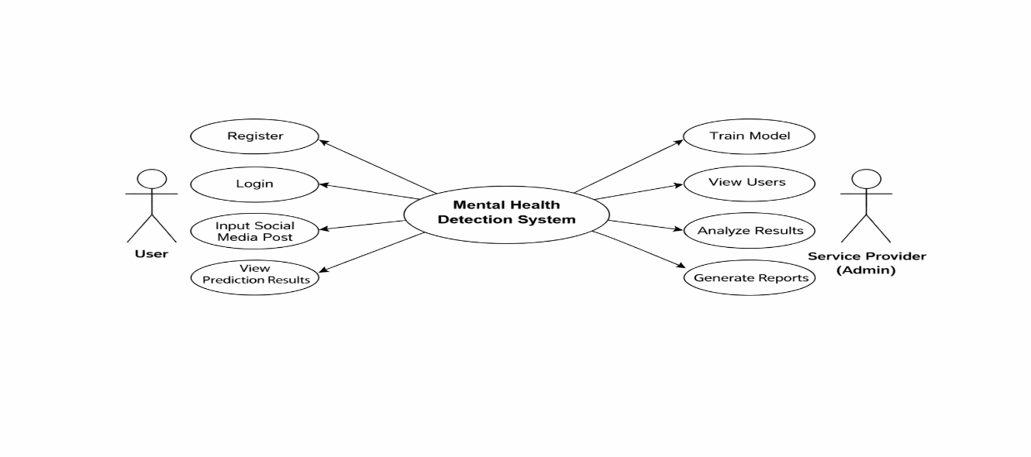
CLASS DIAGRAM:
In A class diagram is a type of structural diagram in UML. It describes the structure of the system by showing classes, their attributes, methods, and relationships among them. It is used to design the static structure of the system.
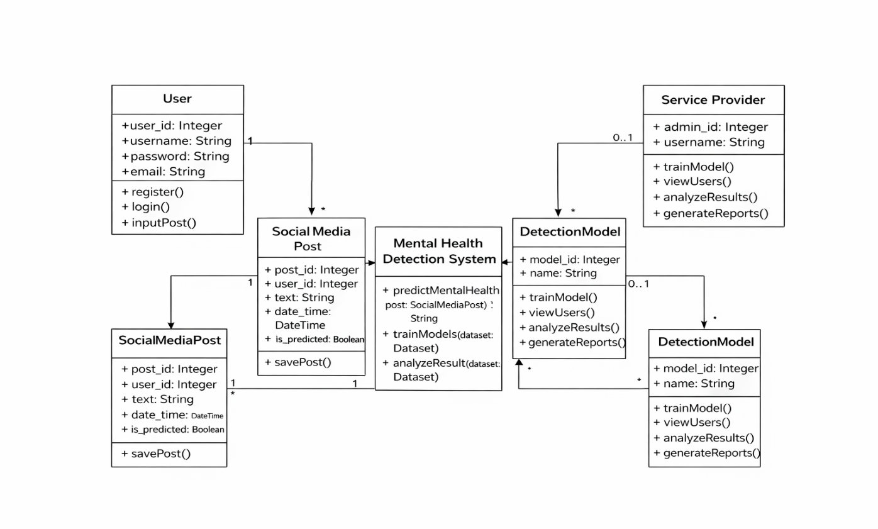

SEQUENCE DIAGRAM:
A sequence diagram is a type of interaction diagram in UML. It shows how processes operate with one another and in what order. It represents the sequence of messages exchanged between objects over time.Sequence diagrams help in understanding the flow of control in the system. It shows how different components communicate with each other to complete a task. It is useful for modeling dynamic behavior.

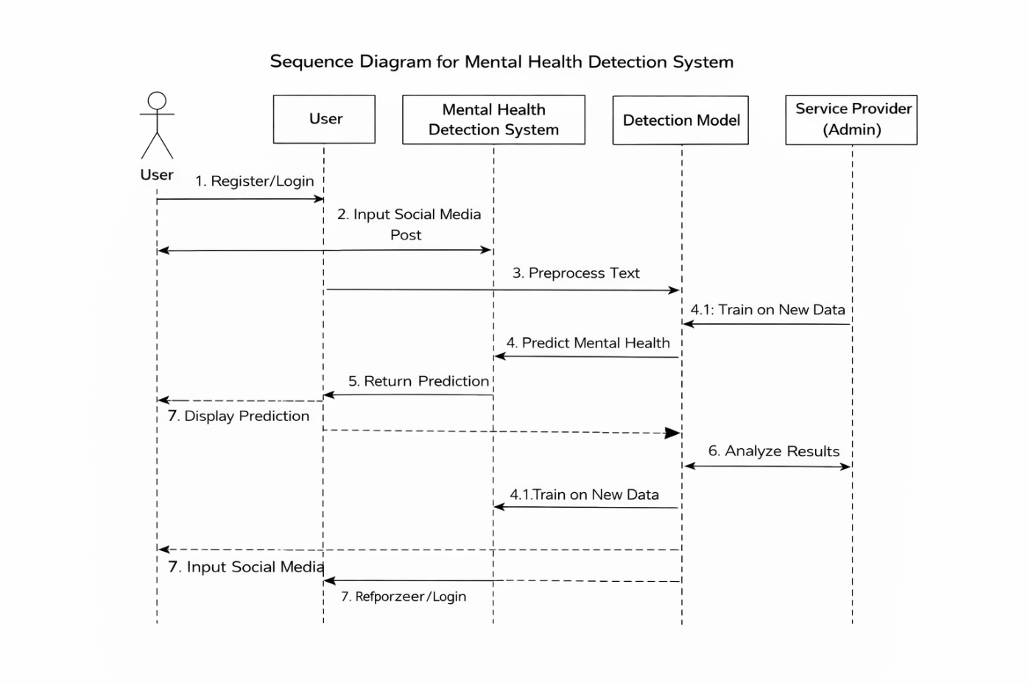

ACTIVITY DIAGRAM:
An activity diagram is a graphical representation of workflows of step-by-step activities and actions. It shows the sequence of activities involved in the system along with decisions and conditions.Activity diagrams help in understanding the overall flow of the system. It represents the process from start to end and shows how different operations are carried out. It is useful for modeling business and operational workflows.

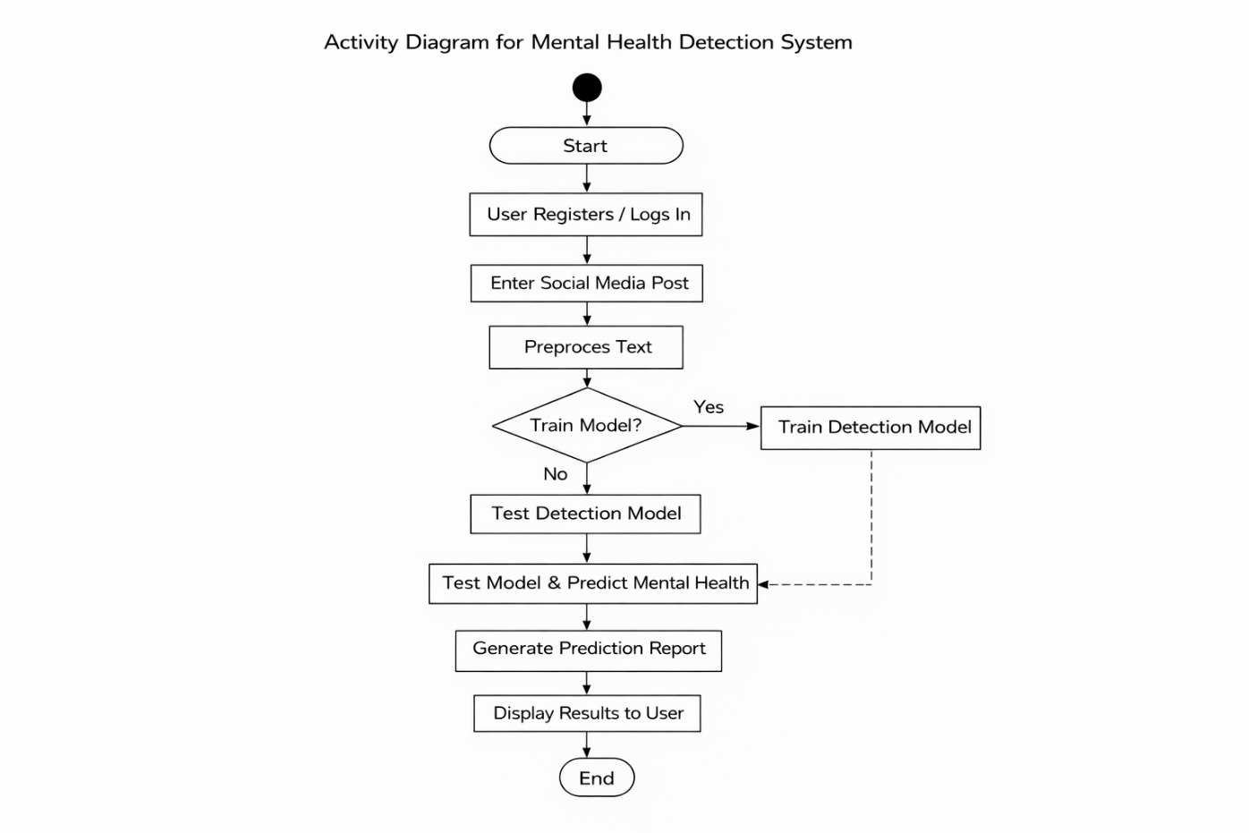

3.4 Stepwise Implementation and Code

SAMPLE CODE
def train_model(request):
detection_accuracy.objects.all().delete()
df = pd.read_csv('Datasets.csv',encoding='latin-1')
# data under nlp
print("Data Processing Under Natural Language Processing (NLP)")
data = []
Labels = []
# Data Processing Under Natural Language Processing (NLP)
for row in df["Posts"]:
# tokenize words
words = word_tokenize(row)
# remove punctuations
clean_words = [word.lower() for word in words if word not in set(string.punctuation)]
# remove stop words
english_stops = set(stopwords.words('english'))
characters_to_remove = ["''", '``', "rt", "https", "â€™", "â€œ", "â€", "\u200b", "--", "n't", "'s",
"...",
"//t.c"]

clean_words = [word for word in clean_words if word not in english_stops]
clean_words = [word for word in clean_words if word not in set(characters_to_remove)]
# Lematise words
wordnet_lemmatizer = WordNetLemmatizer()
lemma_list = [wordnet_lemmatizer.lemmatize(word) for word in clean_words]
data.append(lemma_list)
def apply_results(label):
if (label == 0):
return 0 # No Depression
elif (label == 1):
return 1 # Depression
df['results'] = df['label'].apply(apply_results)
X = df['Posts']
y = df['results']
print("Post Desc")
print(X)
print("Results")
print(y)
cv = CountVectorizer()
X = cv.fit_transform(X)
models = []
from sklearn.model_selection import train_test_split
X_train, X_test, y_train, y_test = train_test_split(X, y, test_size=0.20)
X_train.shape, X_test.shape, y_train.shape

print("Convolutional Neural Network--CNN")
from sklearn.neural_network import MLPClassifier
mlpc = MLPClassifier().fit(X_train, y_train)
y_pred = mlpc.predict(X_test)
testscore_mlpc = accuracy_score(y_test, y_pred)
accuracy_score(y_test, y_pred)
print(accuracy_score(y_test, y_pred))
print(accuracy_score(y_test, y_pred) * 100)
print("CLASSIFICATION REPORT")
print(classification_report(y_test, y_pred))
print("CONFUSION MATRIX")
print(confusion_matrix(y_test, y_pred))
models.append(('MLPClassifier', mlpc))
detection_accuracy.objects.create(names="Convolutional Neural Network--CNN",
ratio=accuracy_score(y_test, y_pred) * 100)
print("Extra Tree Classifier")
from sklearn.tree import ExtraTreeClassifier
etc_clf = ExtraTreeClassifier()
etc_clf.fit(X_train, y_train)
etcpredict = etc_clf.predict(X_test)
print("ACCURACY")
print(accuracy_score(y_test, etcpredict) * 100)
print("CLASSIFICATION REPORT")
print(classification_report(y_test, etcpredict))
print("CONFUSION MATRIX")
print(confusion_matrix(y_test, etcpredict))
models.append(('RandomForestClassifier', etc_clf))
detection_accuracy.objects.create(names="Extra Tree Classifier", ratio=accuracy_score(y_test, etcpredict) * 100)

# SVM Model
print("SVM")
from sklearn import svm
lin_clf = svm.LinearSVC()
lin_clf.fit(X_train, y_train)
predict_svm = lin_clf.predict(X_test)
svm_acc = accuracy_score(y_test, predict_svm) * 100
print(svm_acc)
print("CLASSIFICATION REPORT")
print(classification_report(y_test, predict_svm))
print("CONFUSION MATRIX")
print(confusion_matrix(y_test, predict_svm))
models.append(('svm', lin_clf))
detection_accuracy.objects.create(names="SVM", ratio=svm_acc)
print("Logistic Regression")
from sklearn.linear_model import LogisticRegression
reg = LogisticRegression(random_state=0, solver='lbfgs').fit(X_train, y_train)
y_pred = reg.predict(X_test)
print("ACCURACY")
print(accuracy_score(y_test, y_pred) * 100)
print("CLASSIFICATION REPORT")
print(classification_report(y_test, y_pred))
print("CONFUSION MATRIX")
print(confusion_matrix(y_test, y_pred))
models.append(('logistic', reg))
detection_accuracy.objects.create(names="Logistic Regression", ratio=accuracy_score(y_test, y_pred) * 100)

print("CLASSIFICATION REPORT")
print(classification_report(y_test, y_pred))
print("CONFUSION MATRIX")
print(confusion_matrix(y_test, y_pred))
models.append(('logistic', reg))
detection_accuracy.objects.create(names="Logistic Regression", ratio=accuracy_score(y_test, y_pred) * 100)
print("Random Forest Classifier")
from sklearn.ensemble import RandomForestClassifier
rf_clf = RandomForestClassifier()
rf_clf.fit(X_train, y_train)
rfpredict = rf_clf.predict(X_test)
print("ACCURACY")
print(accuracy_score(y_test, rfpredict) * 100)
print("CLASSIFICATION REPORT")
print(classification_report(y_test, rfpredict))
print("CONFUSION MATRIX")
print(confusion_matrix(y_test, rfpredict))
models.append(('RandomForestClassifier', rf_clf))
detection_accuracy.objects.create(names="Random Forest Classifier", ratio=accuracy_score(y_test, rfpredict) * 100)
print("Gradient Boosting Classifier")
from sklearn.ensemble import GradientBoostingClassifier
clf = GradientBoostingClassifier(n_estimators=100, learning_rate=1.0, max_depth=1, random_state=0).fit(
X_train,
y_train)

Declfpredict = clf.predict(X_test)
print("ACCURACY")
print(accuracy_score(y_test, clfpredict) * 100)
print("CLASSIFICATION REPORT")
print(classification_report(y_test, clfpredict))
print("CONFUSION MATRIX")
print(confusion_matrix(y_test, clfpredict))
models.append(('GradientBoostingClassifier', clf))
detection_accuracy.objects.create(names="Gradient Boosting Classifier",
ratio=accuracy_score(y_test, clfpredict) * 100)
csv_format = 'Results.csv'
df.to_csv(csv_format, index=False)
df.to_markdown
obj = detection_accuracy.objects.all()
return render(request,'SProvider/train_model.html', {'objs': obj})

CHAPTER 4
RESULTS AND DISCUSSION

CHAPTER 4
RESULTS AND DISCUSSION
The developed system successfully analyzes social media text and detects mental health conditions using machine learning techniques. The system processes user input by applying Natural Language Processing techniques such as tokenization, stop word removal, and lemmatization. The processed data is converted into numerical form using feature extraction methods and then passed to machine learning models for prediction.
The system uses multiple machine learning algorithms such as Convolutional Neural Network (CNN), Extra Tree Classifier, Support Vector Machine (SVM), Logistic Regression, Random Forest, and Gradient Boosting. Each model is trained and tested using the dataset, and their performance is evaluated using accuracy metrics. The results show that Logistic Regression and CNN provide better accuracy compared to other models.
The system stores the prediction results in the database and displays them through a user interface. It also calculates the ratio of mental health conditions such as depression and non-depression based on user data. The results indicate that approximately 33.33% of users show signs of depression, while 66.66% of users are classified as non-depressed.
The system provides graphical representation of results using charts, which helps in better understanding of data distribution and model performance. The service provider can view user details, prediction results, and model accuracy through the system interface.
The overall results demonstrate that the system is capable of effectively detecting mental health conditions from social media text. However, the performance of the system may vary depending on the quality of input data and the diversity of language used in social media posts. Despite these limitations, the system provides a useful approach for early detection and monitoring of mental health issues.

CHAPTER 5
CONCLUSION

CHAPTER 5
CONCLUSION
5.1 Conclusion and Future Enhancement
The proposed system successfully implements a mental health detection model using social media data and machine learning techniques. The system analyzes user-generated text and identifies mental health conditions such as depression and non-depression. The implementation begins with collecting social media data, followed by preprocessing using Natural Language Processing techniques such as tokenization, stop word removal, and lemmatization.
Feature extraction is performed using CountVectorizer to convert textual data into numerical form. The system applies multiple machine learning algorithms such as Convolutional Neural Network (CNN), Extra Tree Classifier, Support Vector Machine (SVM), Logistic Regression, Random Forest, and Gradient Boosting for classification. The performance of each model is evaluated using accuracy metrics, and the results are stored in the database.
The system provides an interface for users to input text and view prediction results. It also allows the service provider to analyze model performance, view user data, and generate reports. The system achieves good accuracy in detecting mental health conditions and demonstrates the effectiveness of machine learning techniques in analyzing social media data.
In future work, the system can be improved by using larger and more diverse datasets to increase accuracy. Advanced deep learning models such as BERT and transformer-based models can be implemented for better contextual understanding. The system can also be extended to support multilingual data and include additional features such as real-time monitoring and integration with mental health support systems.

.

REFERENCES

REFERENCES
[1] World Health Organization, “Suicide: Facts and Figures Globally,” https://www.who.int, 2022.
[2] J. M. Havigerová, J. Haviger, D. Kučera, and P. Hoffmannová, “Text-Based Detection of the Risk of Depression,” Frontiers in Psychology, vol. 10, 2019.
[3] T. Zhang, A. M. Schoene, S. Ji, and S. Ananiadou, “Natural Language Processing Applied to Mental Illness Detection: A Review,” NPJ Digital Medicine, vol. 5, 2022.
[4] M. Tadesse, H. Lin, B. Xu, and L. Yang, “Detection of Depression-Related Posts in Reddit Social Media Forum,” IEEE Access, vol. 7, 2019.
[5] P. Burnap, W. Colombo, and J. Scourfield, “Machine Classification and Analysis of Suicide-Related Communication on Twitter,” ACM Conference on Hypertext and Social Media, 2015.
[6] S. Chancellor and M. De Choudhury, “Methods in Predictive Techniques for Mental Health Status on Social Media,” NPJ Digital Medicine, vol. 3, 2020.
[7] X. Chen, M. D. Sykora, T. W. Jackson, and S. Elayan, “What About Mood Swings: Identifying Depression on Twitter,” The Web Conference, 2018.

CONFERENCE/JOURNAL PUBLICATION

GitHub Link

- Driver Drowsiness Detection using CNN, Keras & OpenCV
https://github.com/abhishek351/Driver-drowsiness-detection-CNN-Keras-OpenCV
- Driver Drowsiness Detection using Haar Cascade & Deep Learning
https://github.com/SHAMSUNDAR20/Driver-drowsiness-Detection-using-Haar-Cascade-Algorithm-in-Deep-Learning
- Real-Time Driver Drowsiness Detection System
https://github.com/AnshumanSrivastava108/Real-Time-Drowsiness-Detection-System
- Driver Drowsiness Detection using CNN (Python & OpenCV)
https://github.com/satyamgeek/driver_drowsiness_system_CNN

